**FOURTH INCREMENT REPORT**

**MUSIC PLAYER**

1. **Introduction:**

This topic of developing a music app has come from the various reviews taken from the people who are continuously involving in work without any rest. Those people almost 80% of the people needs to get refreshment in order to soothe themselves from those work tensions will be getting relaxation upon listening to music. Basing on such benefits and with an intension to relieve such kind of people to be like getting relief, we are introducing this application. In this application, one can have many options to select songs and various varieties upon their interest. Many extra features will be added to our project like sharing the song which he wants to forward through social media like Facebook, WhatsApp and many available sources.

1. **UML**

# 2.1 UML Class diagram

## 2.1.1 Login Page

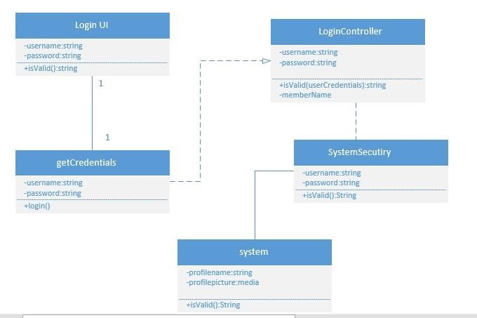

## 2.1.2 Registration_Activity

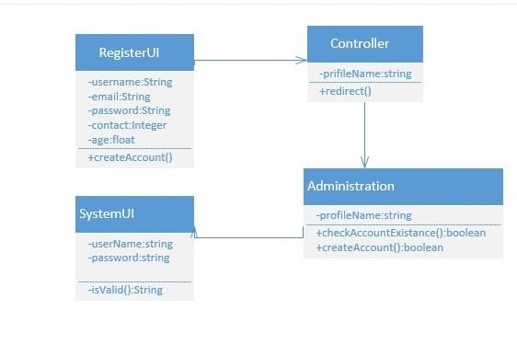

2.1.3 Music player

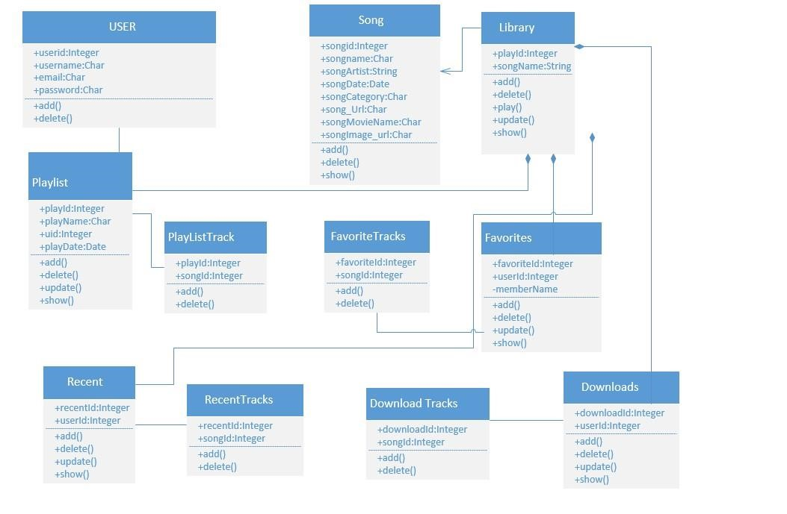

# 2.2. UML Sequence diagram

## 2.2.1. Login

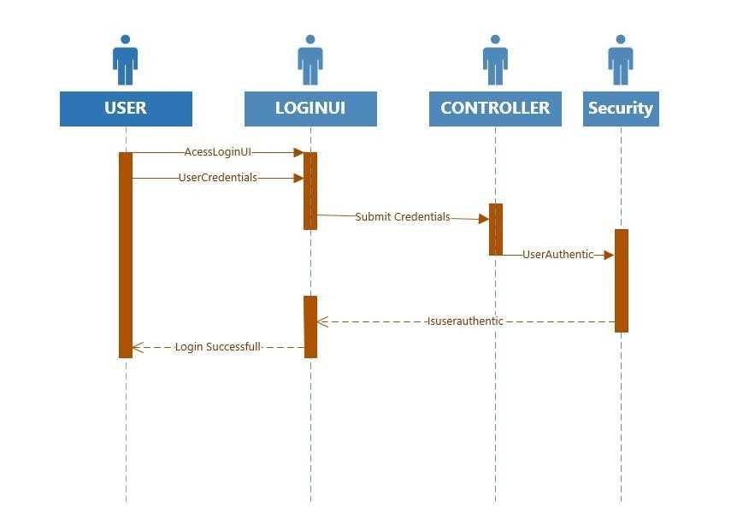

## 2.2.2. Logout

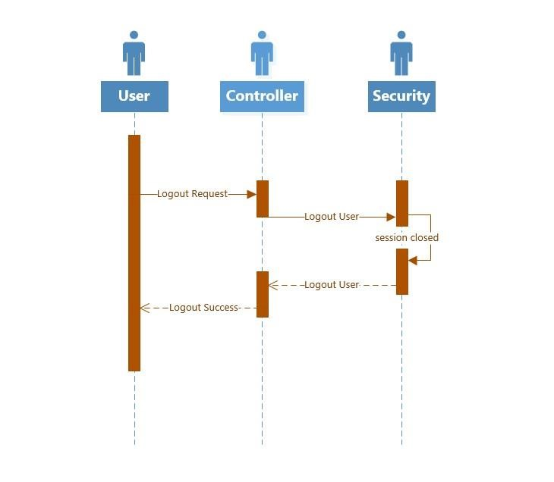

## 2.2.3. Registration

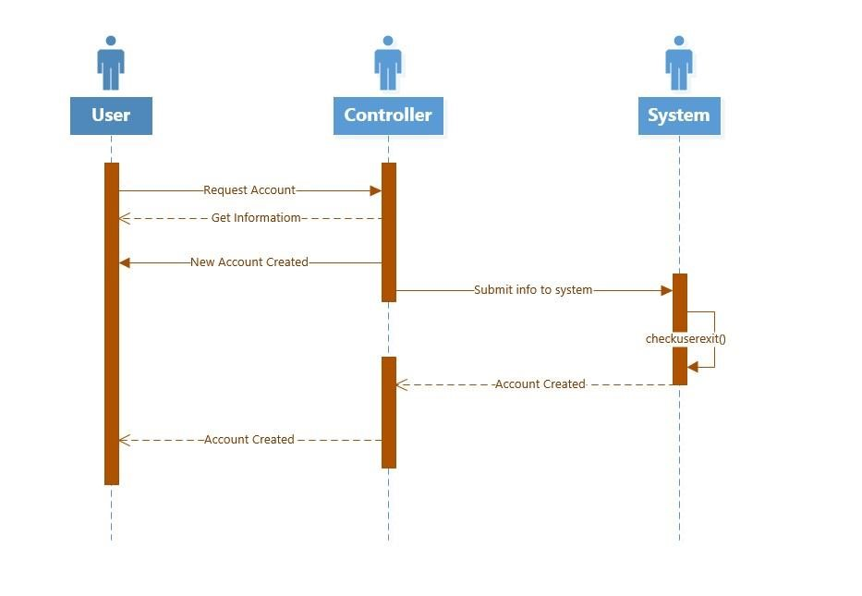

## 2.2.4. Music Player

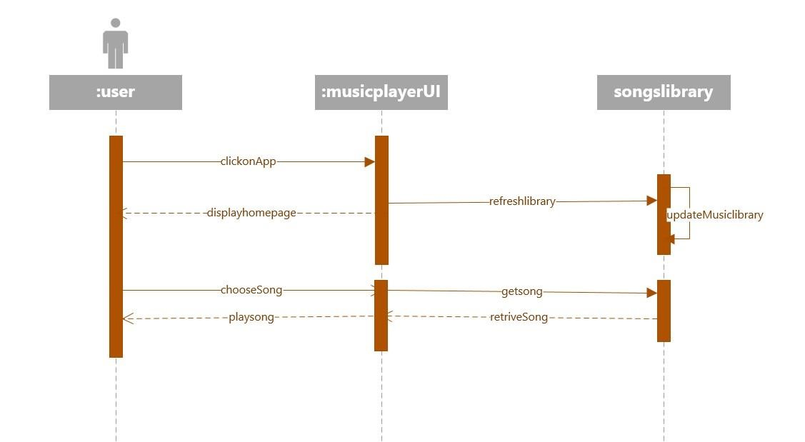

## 2.2.5. Music_player2

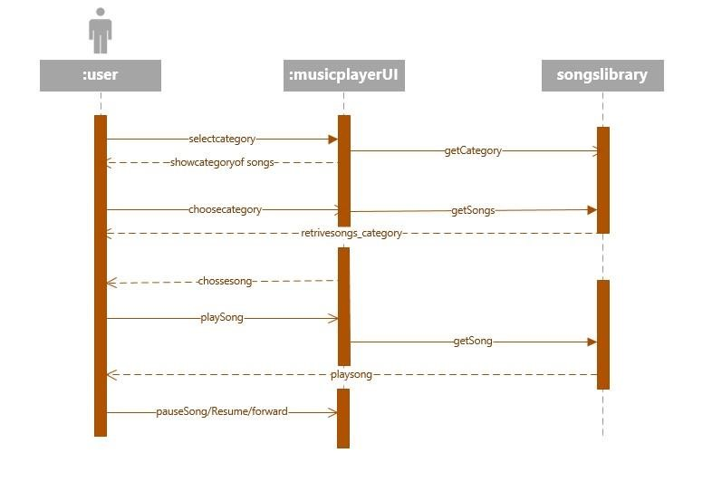

2.3. UML State Diagram

## 2.3.1. Login

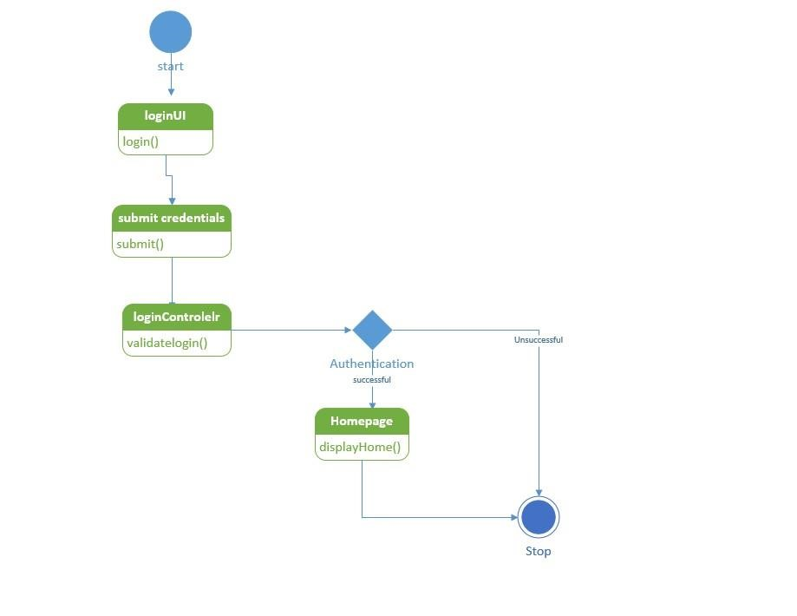

## 2.3.2. Logout

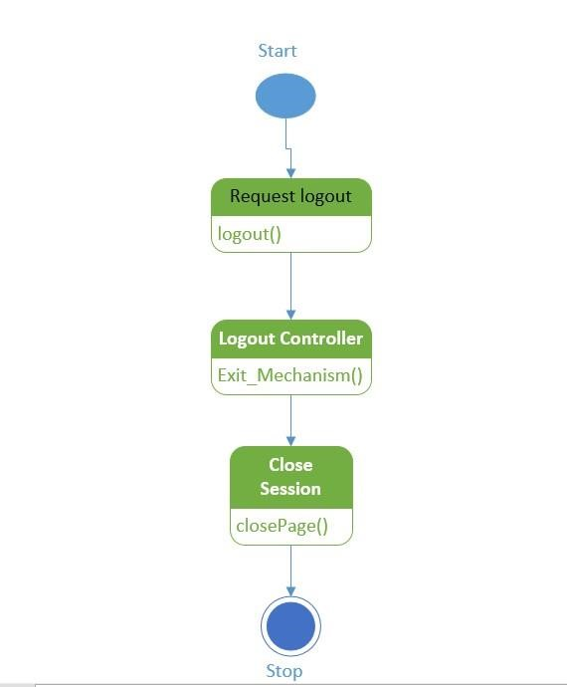

## 2.3.3. Registration

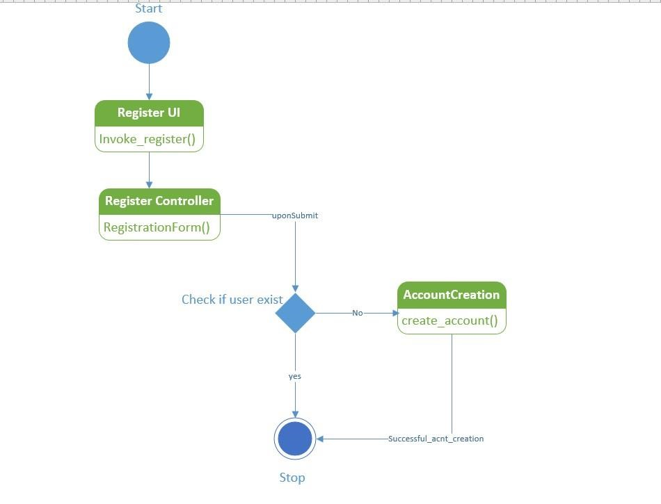

**2.3.4 Activity Page:**

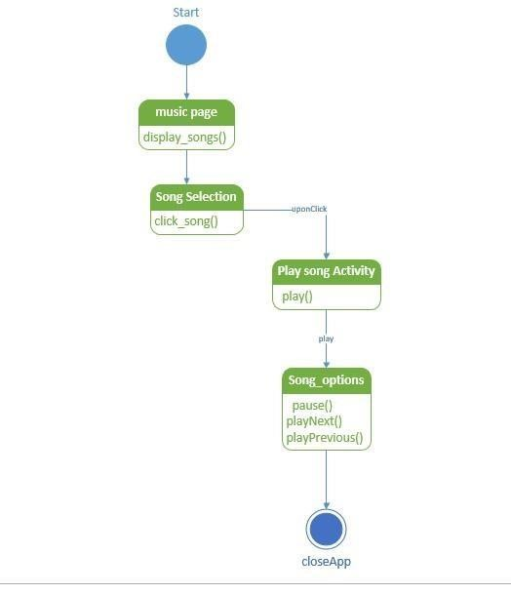

# 3 WIREFRAMES FOR MUSIC PLAYER

## 3.1 Login

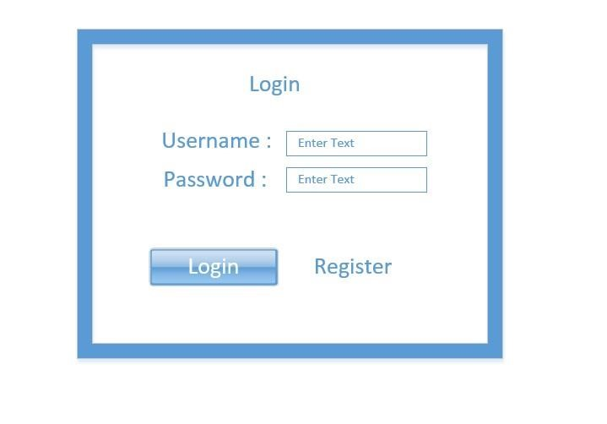

## 3.2 Registration

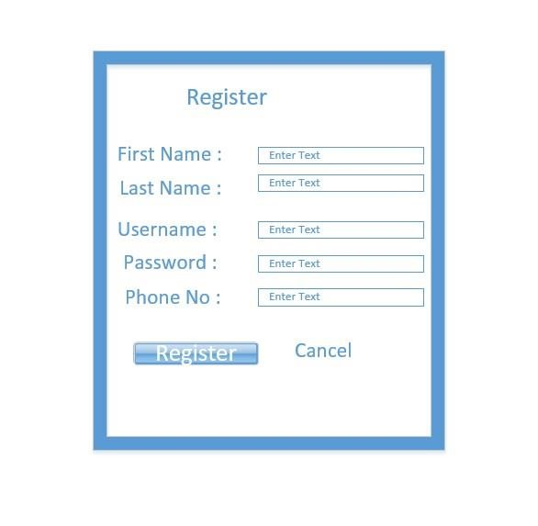

## 3.3 Music player

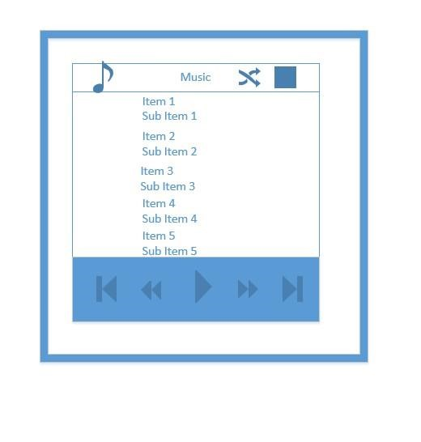

## 3.4 Music player search activity wireframe

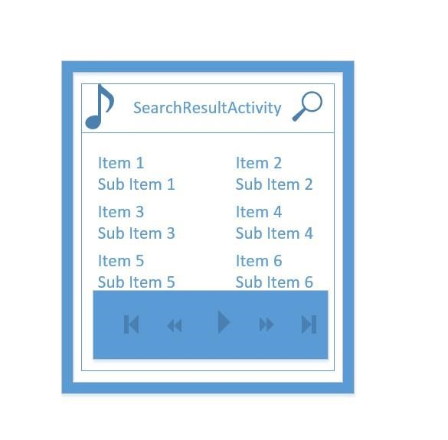

## 3.5 Music player_Category

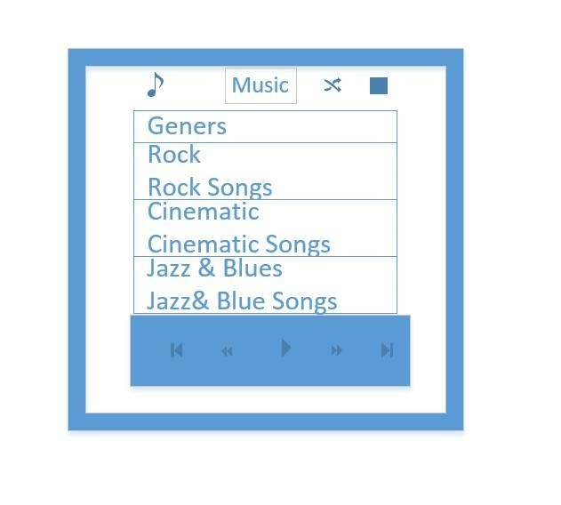

**4 Architecture/Design**

## 4.1. ZenhubTool

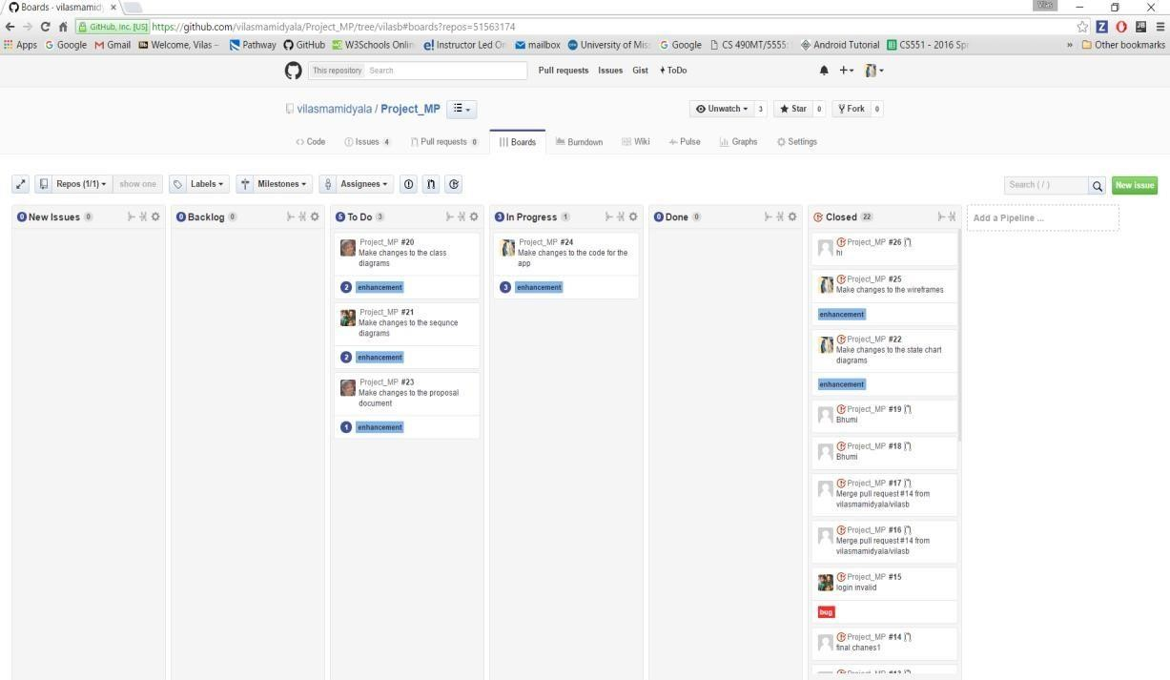

## 4.2 Issues

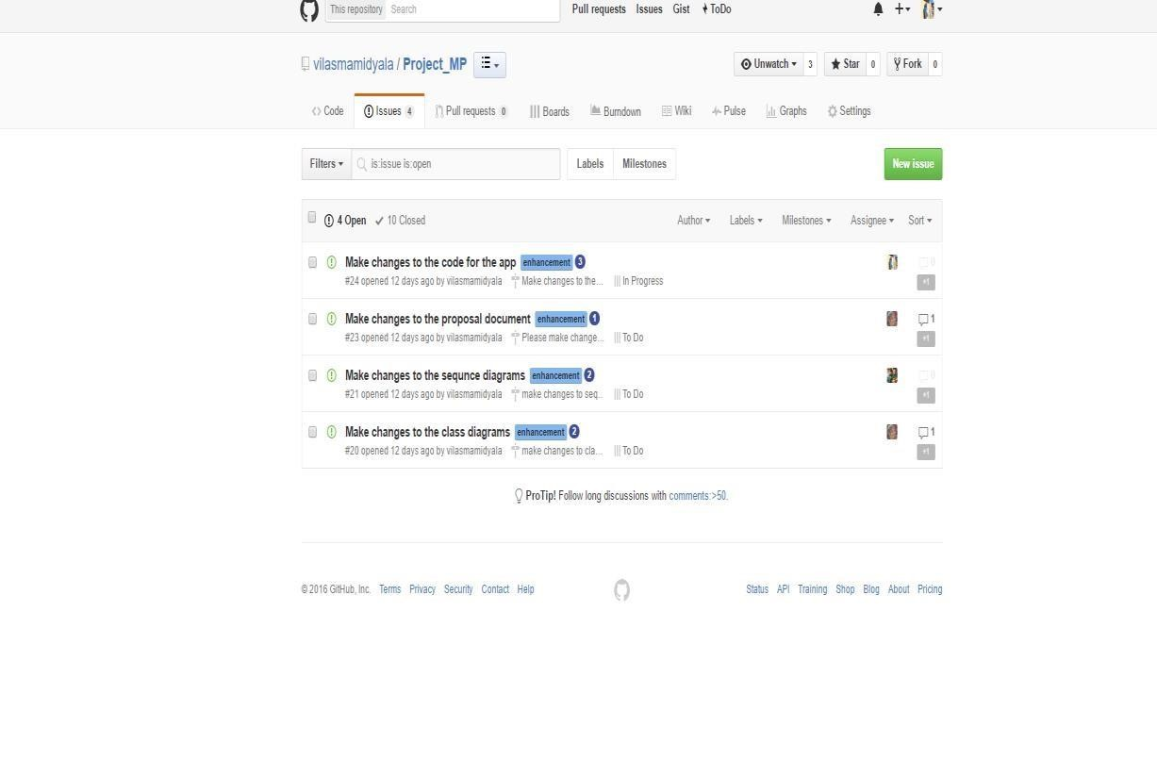

## 4.3 Milestones for App

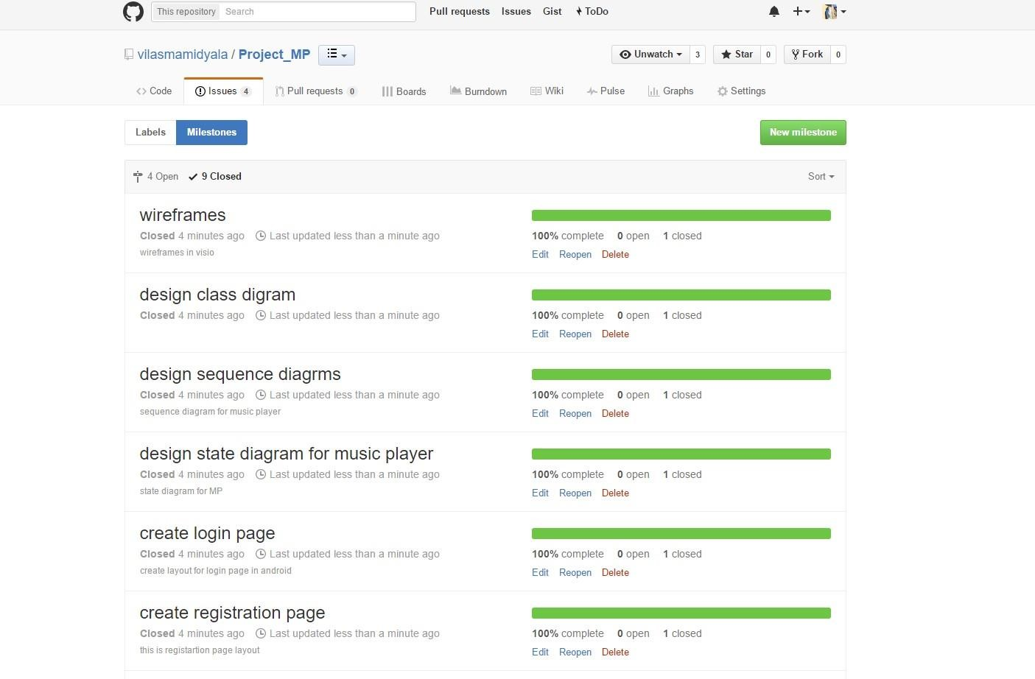

## 4.4 Bug in Zenhub tool

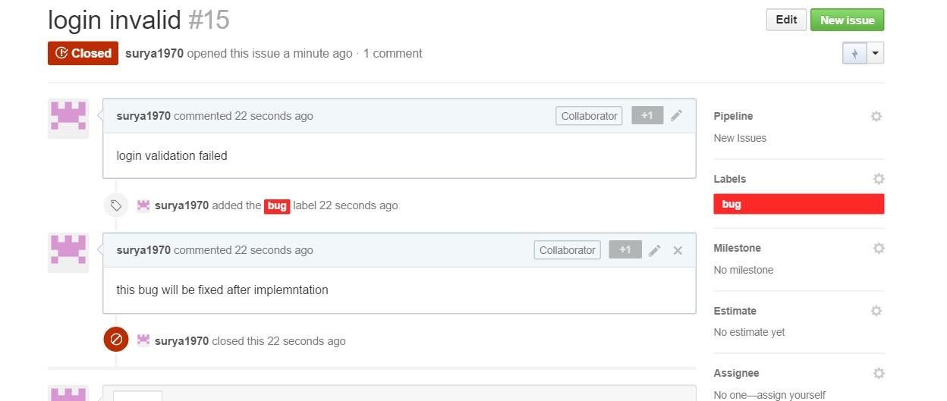

4.5 Github

Three branches: vilasb, dineshb, and bhumi:

[https://github.com/vilasmamidyala/Project_MP/issues#boards?repos=51563174](https://github.com/vilasmamidyala/Project_MP/issues?repos=51563174#boards)

<https://github.com/vilasmamidyala/Project_MP>

**4.6 Burndown graph:**

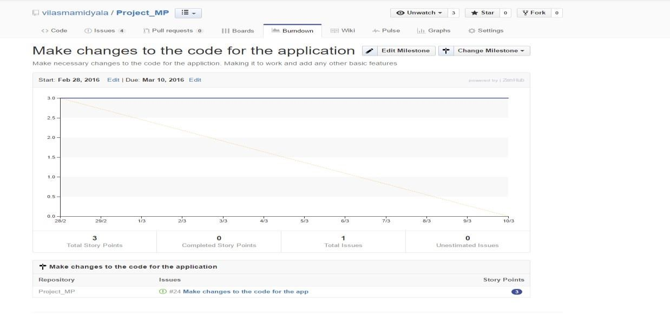

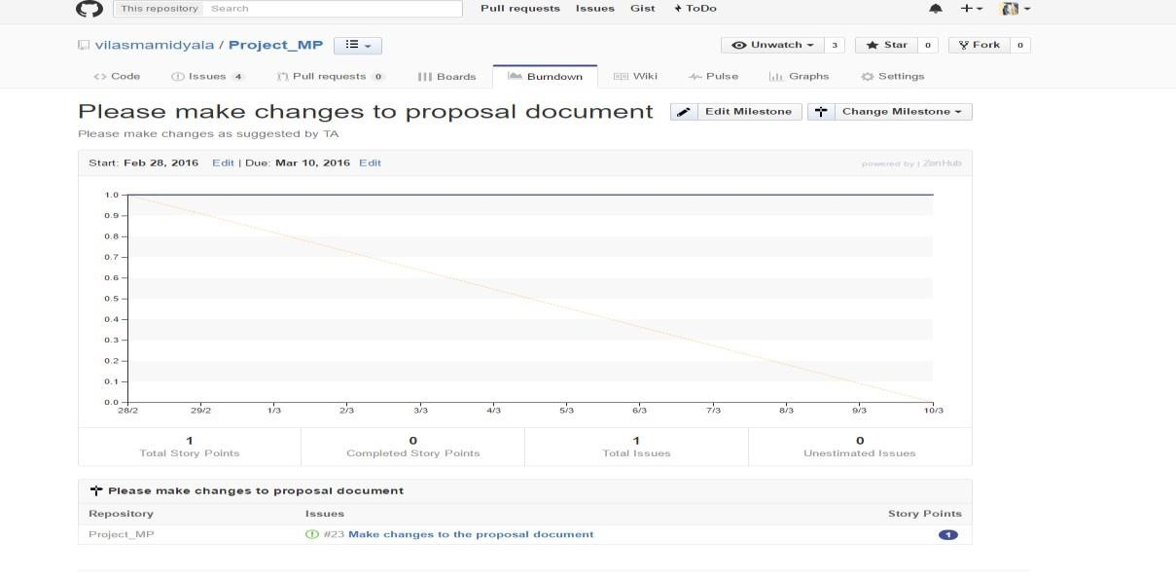

**5. Project Plan – MusicPlayer**

**1 Project Introduction Objective:**

In today’s scenario, it is quite common to get refreshment over this competitive and workaholic world. One might have a constant search of relaxation through various form of entertainment. Out of all those, listening to music has becoming the best way to switch to normal mode instantly. Thus, here we are creating an application which works for the same purpose as discussed above with many functionalities and giving access to users to choose whatever they want.

**Project Goals:**

Our application involves many functionalities like categorizing the songs based on timings and the type of song. We do have both facilities like listening the song from internet or else can download and listen if user wants for long time listening. Contextualization is the another thing which we would like to implement. This is to give user song suggestions and based on user context. Another interesting thing is to make suggestions based on time and geographical location. It means user can listen to songs based on location specific popular songs.

**Inbuilt Functions:**

* Library which has many kinds of selections.
* Library also contains Albums, Favorites, Recent, Downloads, Pop, Rock and Classic.
* Each category has its own tracks internally.
* All these categories do have again inner list of those songs which provides inner details of each song like singer, movie, song Id, and the date it was released in to market.

**Operative Path:**

**Step1:** User needs to be login the app. If one is a new visitor to the app he has to get register himself in to the app so that he an access all the facilities of the application.

**Step2:** In order to get any kind of song, we need to open library and then need to select the type of category.

**Step3:** As soonas he selected the type of category, he will be given many options in that category to choose and many details regarding the song will be displayed.

**Step4:** Upon his selection after considering all these classifieds, there are two options like Download and play now in front of him to choose with.

**Step5:** Out of those two, basing on his interest and usage he may choose one of that or both to proceed with.

**Step6:** He canupload a new song to the application if he really would like to as he can be provided with Upload option.

**Project Goals:**

* Creating a user login page to those who has already account with previous registration.
* Creating another registration for those who do not have account.
* Designing the home page in which one can see all the classifieds listed in the app.
* This home page should be in a way that Out of selection, each song has its own functionalities like play, pause, next song and previous song which work upon a single click.
* We need to add functionality that all the songs will be displayed as we listed internally and under each list there might be a sub list to choose more options.
* Assigning store data provides choosing play list option, user can get all the previously played and recently played songs with his account credentials.
* One more extra feature that we are supposed to include is sharing option. Here, our applications have been designing in a manner to share all the social network options like Facebook, Twitter, LinkedIn and WhatsApp.
* Location based and time based songs suggestions to the user as explained in detail earlier.
* Most important thing contextualization, which is to give the suggestion to the listener. This feature will add the beauty to the music player app.

**Tools, Languages and Softwares’ Required :**

* Android studio and Eclipse and APIs
* Java
* DB: Mongo Db
* HTML, CSS3, ANGULARJS.

# App function

## 1.1. Login/logout

Let user login through username and password. User also can logout whenever they want. If the user forgets password, he/she can retrieve it through email. The system will send the verification code to let the user to reset password.

## 1.2. Registration

If a user does not have an account, the user can register. In this step, the user needs to provide personal information to create an account.

## 1.3. Selection

In library page, user can select one of the many options. When one category is selected, the user will first see list of songs under that category. The user can first input the parameters like song id or song name and then know the availability of songs that the app has. The user can also make a record to the database like saving all the recently played songs under play list.

**1.4. Suggestion:**

When user decides what song he wants, he will be provided with many options like play online, download the song and even he has the option to share the song to whom he wants to send through social sites.

## 1.5. History/Reminder

User can see all the recorded and played songs information. The system provides the graphic analysis. Also, the suggestion history is provided as recently played.

# 2. Stories (features): Scenario & Use case specification

## 2.1. Research

Although we have many music apps today, we still miss some functionalities in each app. Considering such cases in order to include all the features in a single app we came up with designing music player. We are including the basic features of a music player along with interesting things like you can share the song in a social network sites. We can also send songs to our friend using this app.

**2.2. Architecture of the Music Application and its Design** It has divided into two parts: ***User Interface design*** and s***ystem design***. For ***USER INTERFACE design***, it has below User interface specified:

1. Register: Design mockup and wireframe for register activity view with user information fields.
2. Login: Design mockup and wireframe for login activity view with basic functionality such as user name, password, and login button.
3. Music player: Design mockup and wireframe for music player activity view.
4. Music player search activity: Design mockup and wireframe for search activity view.
5. Music player library activity: Design mockup and wireframe for library activity.
6. Music player playlist activity: Design mockup and wireframe for playlist activity.
7. Music player share activity: Design mockup and wireframe for share page activity.

For ***system design***, it has below activities:

1. Login: Design sequence and state diagrams when a user login into the system.
2. Logout: Design sequence and state diagrams for logout scenario.

1. Music player home page activity: Design sequence and state diagrams for home page scenario;
2. Music player search activity: Design sequence and state diagrams for music player search activity
3. Music player library activity: Design sequence and state diagrams for Music player library
4. Music player share activity: Design sequence and state diagrams for Music player library

**2.3. Software and hardware Requirements:**

This part includes three tickets:

1. Setup database (Hardware): Setting up database with needed schema.
2. Setup software development workspace: Setting up GitHub repository and invite collaborators
3. Setup Zen hub and other data base tools.

**2.4. Development**

Layouts for currently developed pages:

# Welcome Page :

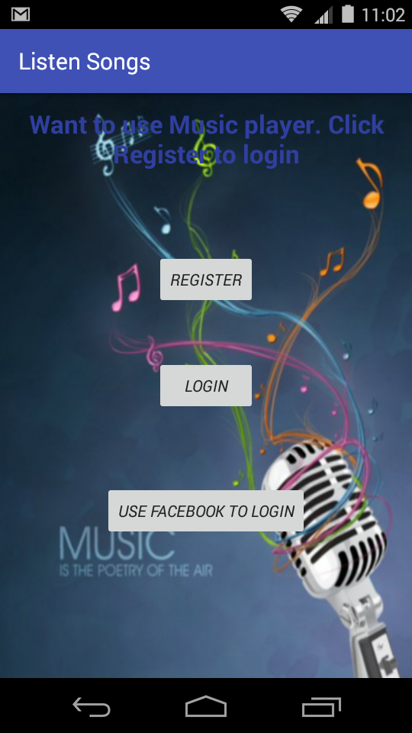

**Registration page:**

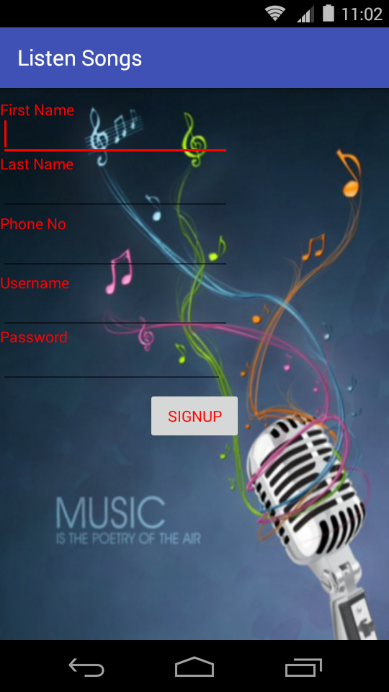

**Registration Filled Page :**

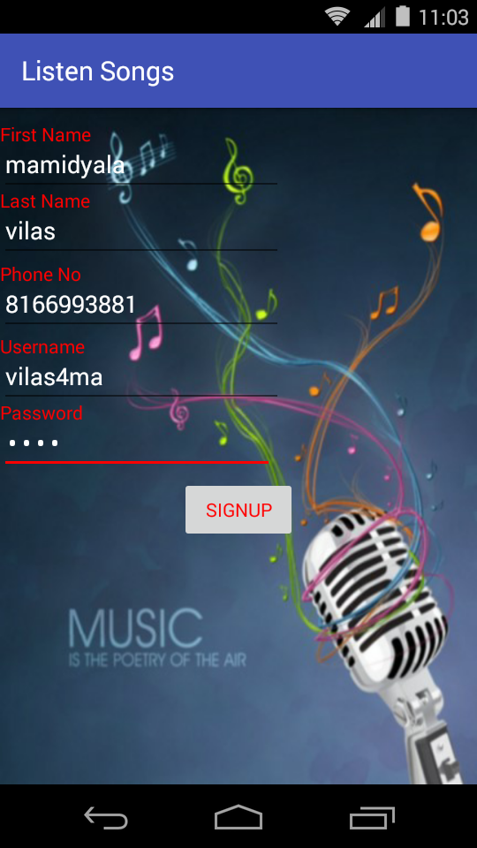

**Successful Registration Page:**

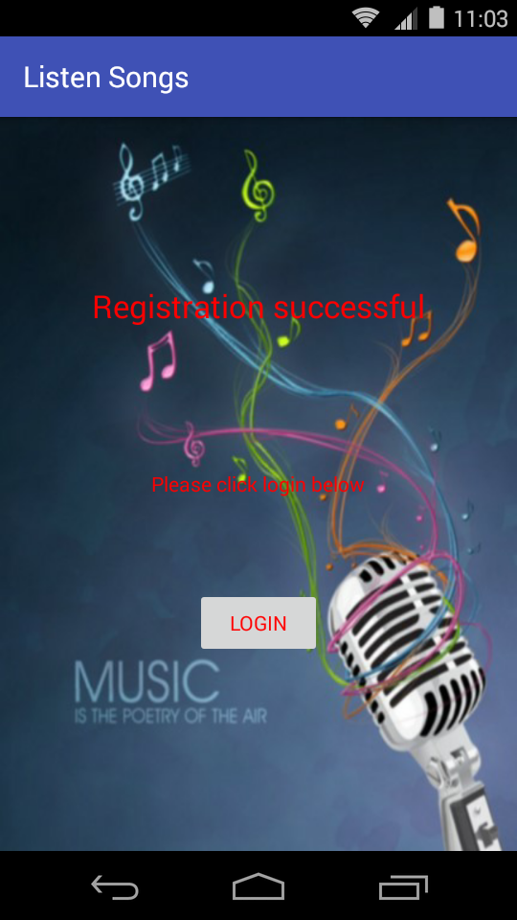

**Facebook login page:**

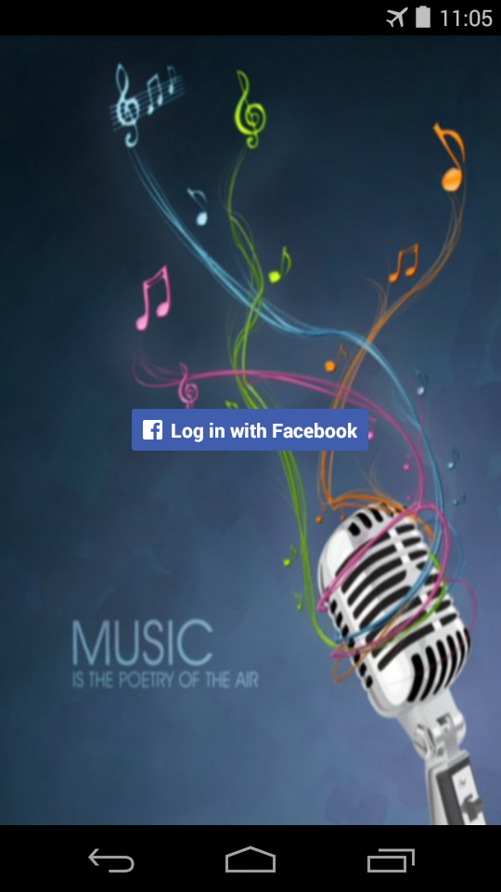

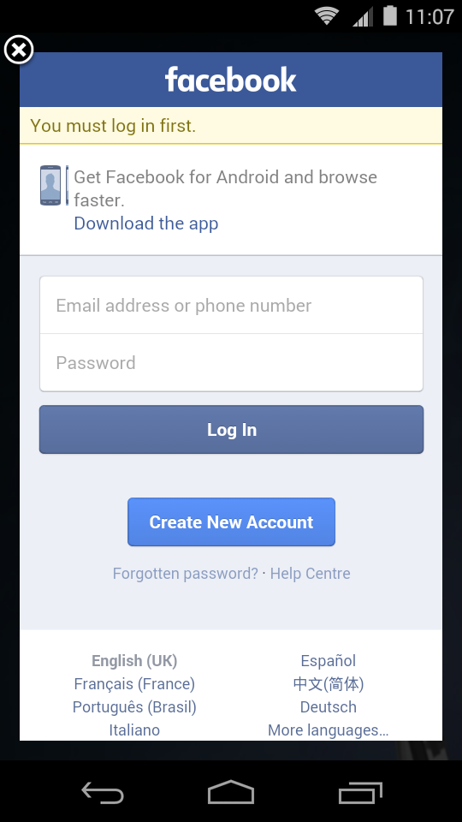

**Facebook login filled page:**

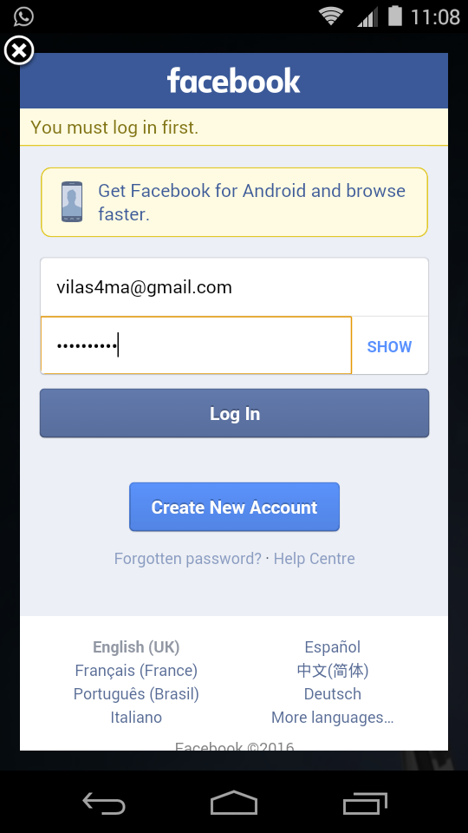

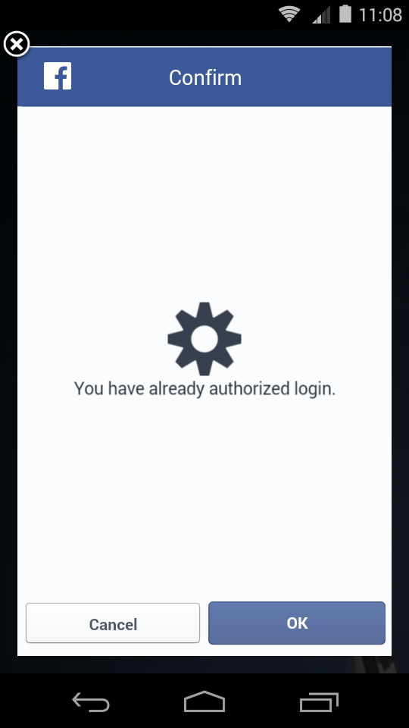

LoginPage: 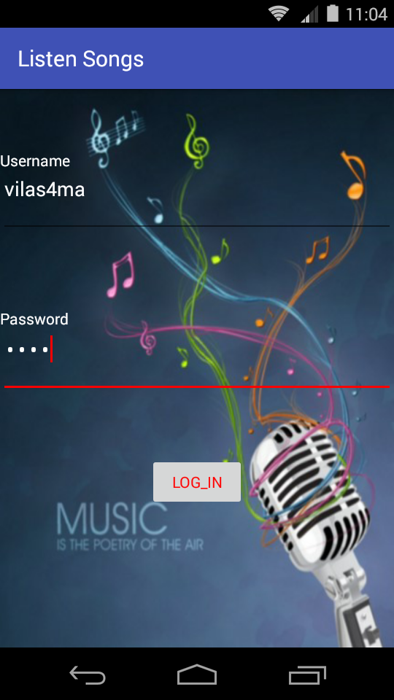

Songs Home Page :

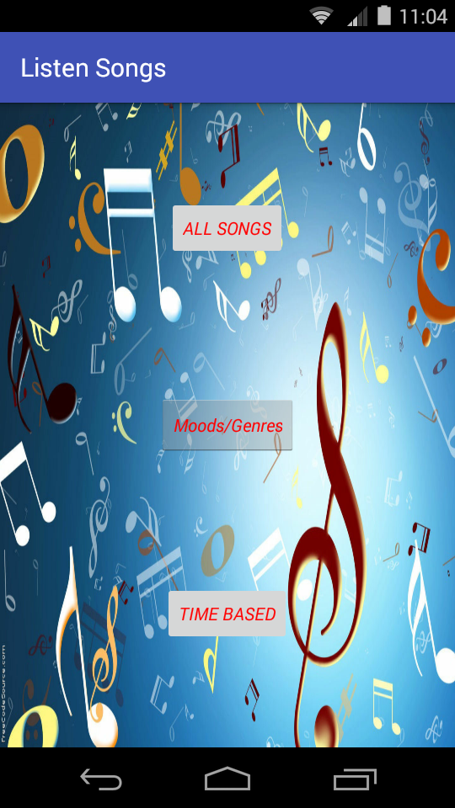

All songs Page :

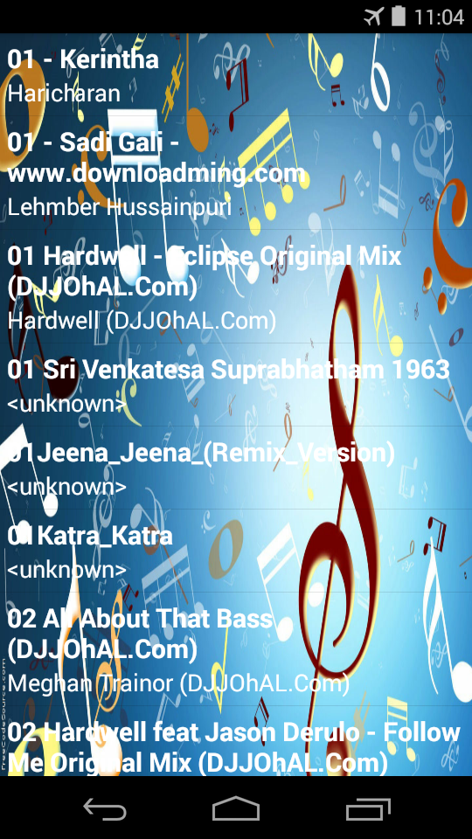

**Genres Selection Page :**

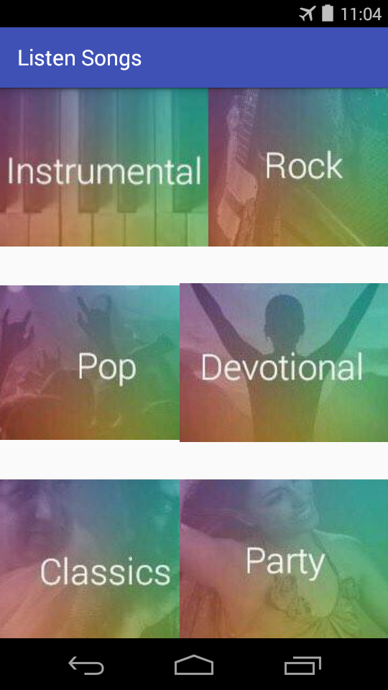

**Devotional Genre Songs Page :**

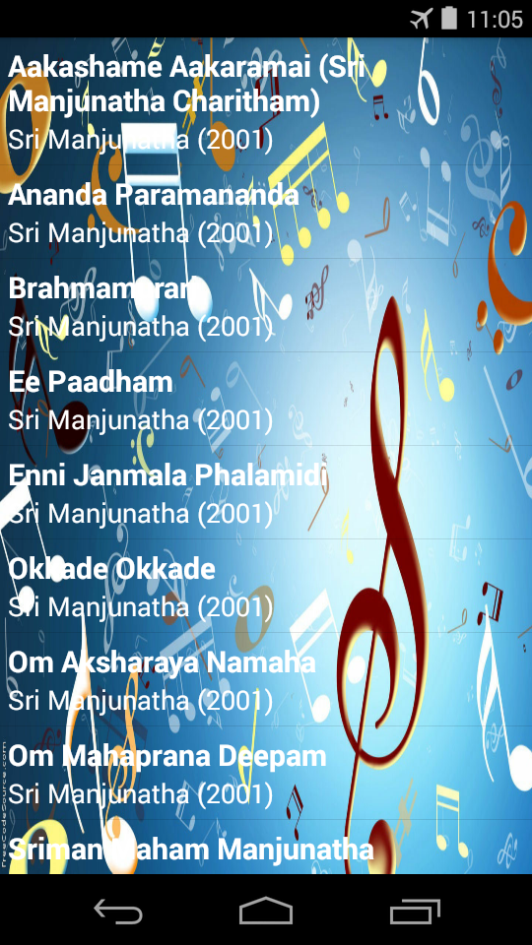

Rock Genre Songs Page :

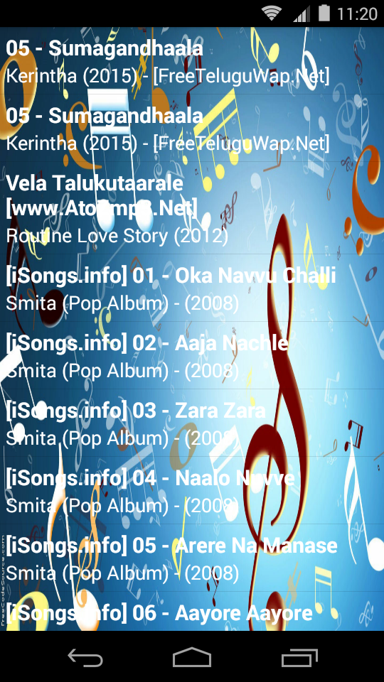

Instrumental Songs:

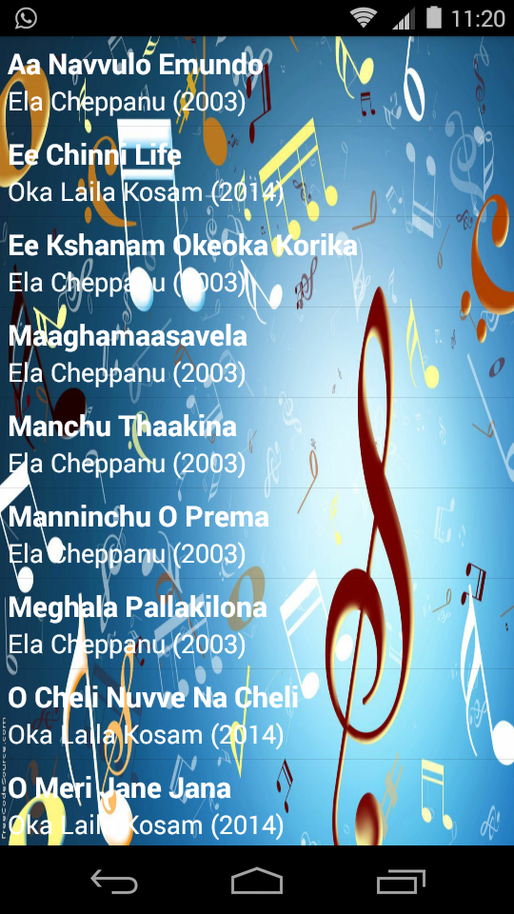

Pop songs page:

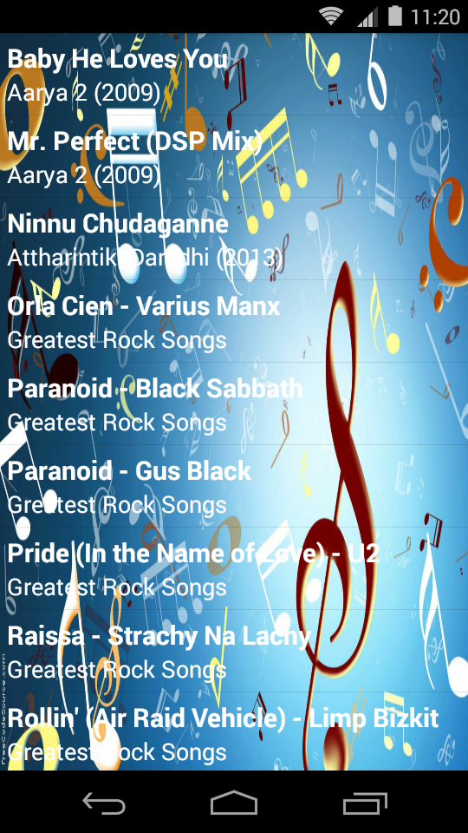

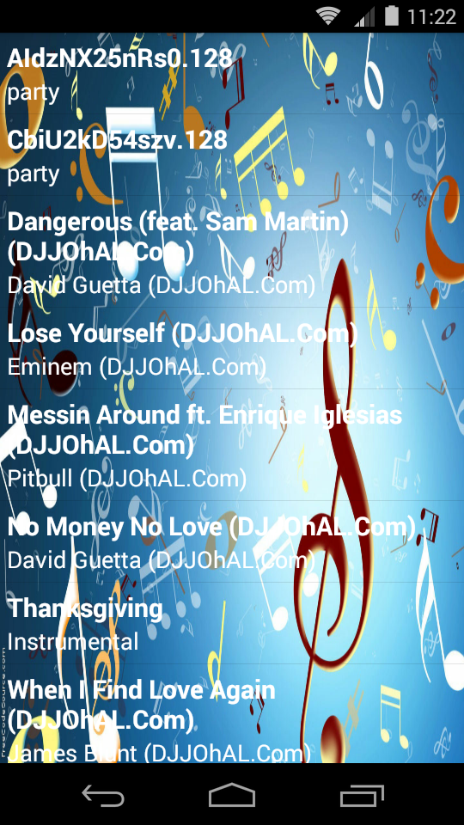

Classic page:

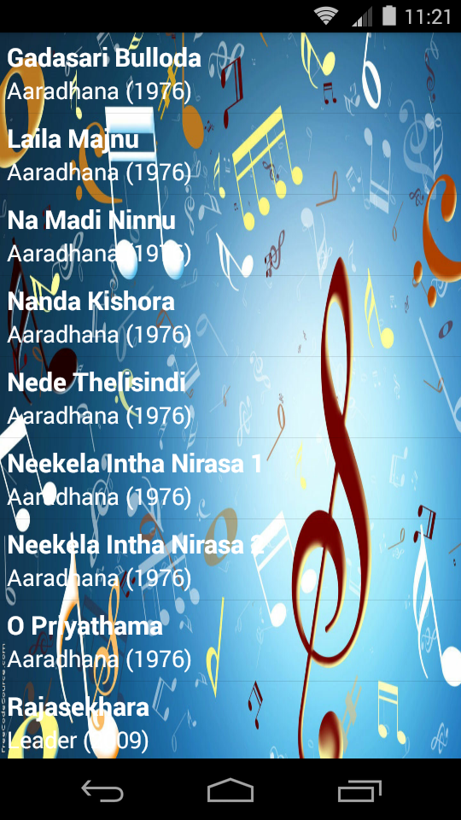

Party Genre Songs Page :

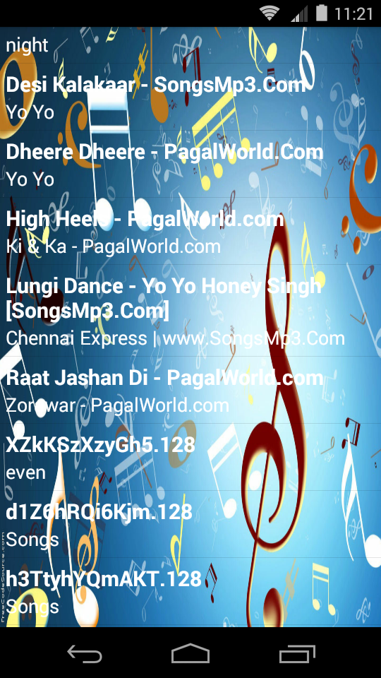

Time based categorization:

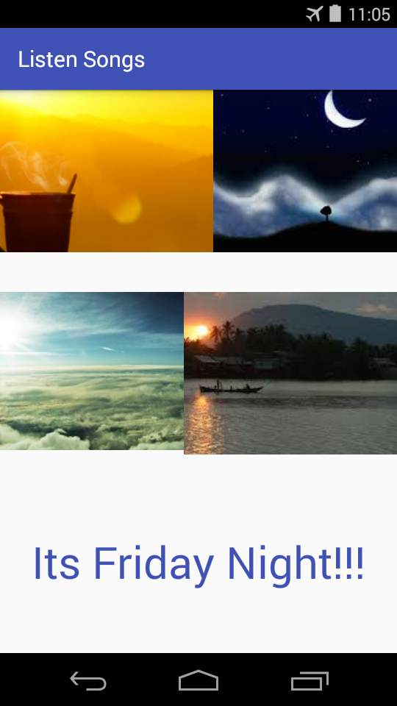

Morning songs:

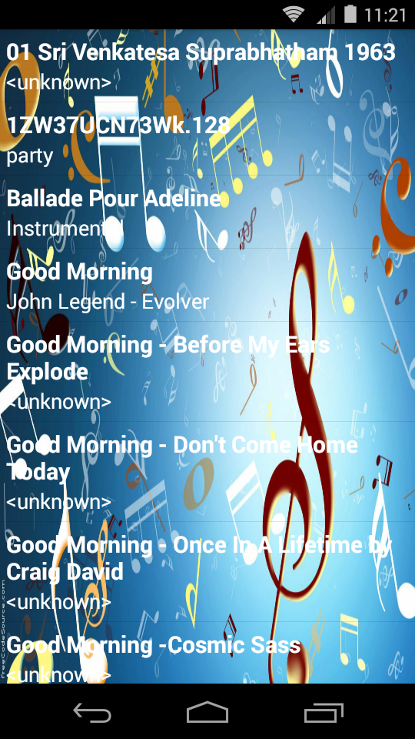

Afternoon songs:

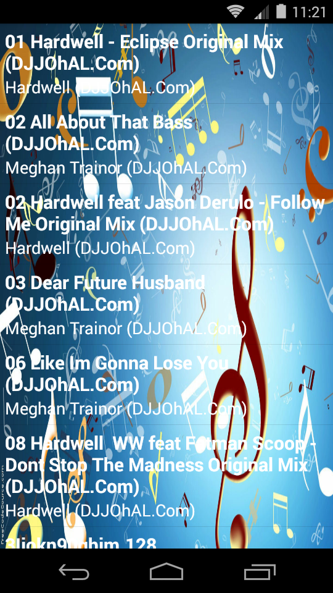

Evening songs:

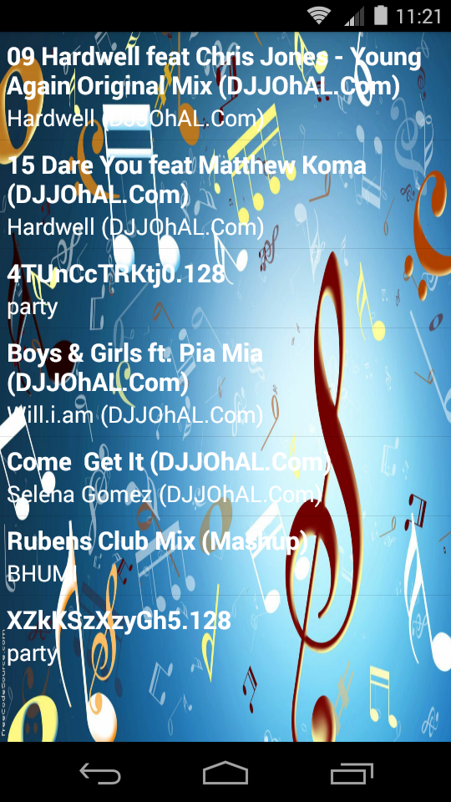

Night Songs:



Song played:

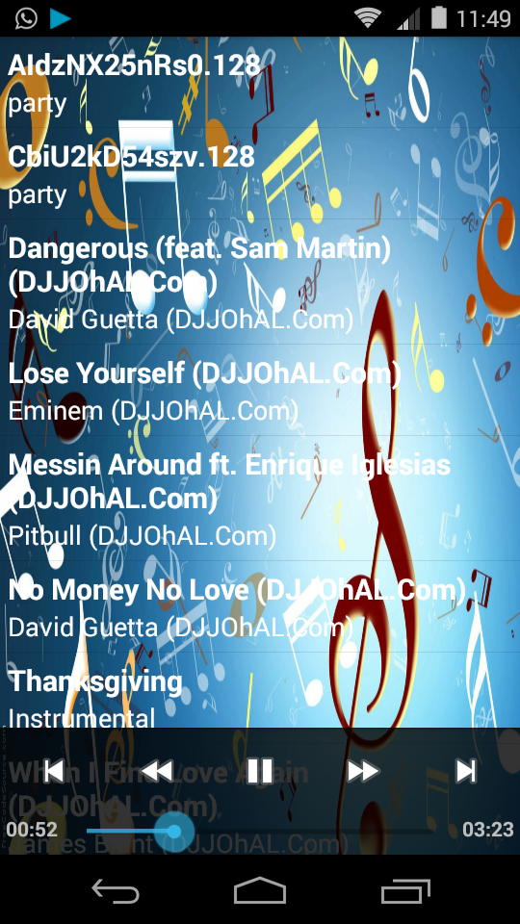

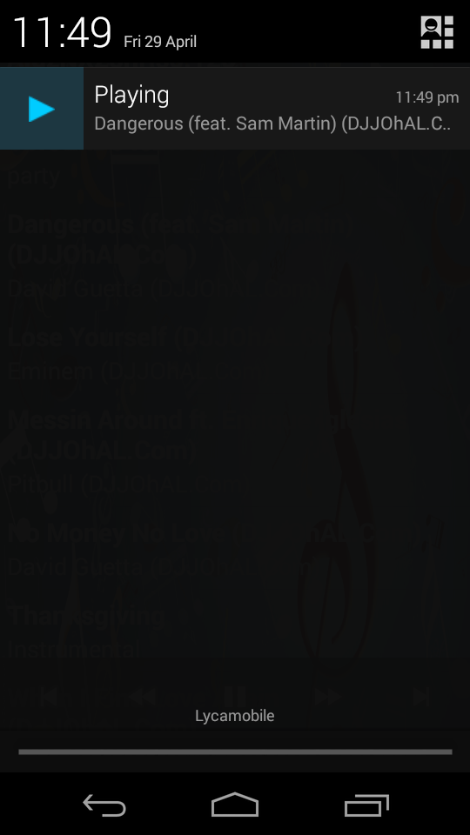

**2.5. Bug:**

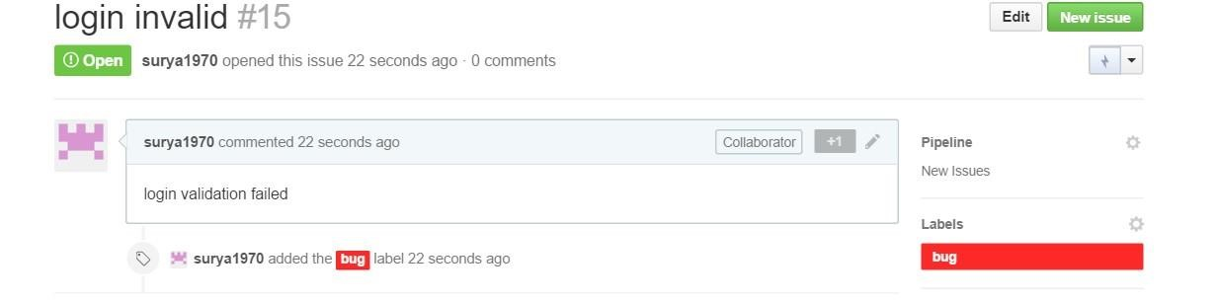

## 2.6. Database

We are using the SQlite database as storage and we will use other databases in future if we need other to be added.

1. **The First Four Increments:**

**3.1. Increment 1-- Requirement Analysis and Design the application** 1) Introduction about Music player and collect basic information needed 2) Setup Zenhub Tool and Github for every team member.

* 1. Design class diagrams.
  2. Design sequence diagrams.
  3. Design state diagrams. 6) Design WireFrames.

## 3.2. Increment 2—Implementation/ System Testing

1. Implement Login/logout/Registration/ Registration validation.
2. Implement Music player main page.
3. Implement Javas codes for basic functionalities for the above needs.
4. Test Login/logout UI/Registration/Registration validation. 5) Test Music player pages.

## 3.3. Increment 3 – Coding/Testing

1. Implement Music player other features such as search activity.
2. Implement categorization of songs.
3. Implement social network sharing.
4. Implement playlist page
5. Test Music player search activity page.
6. Test categorization page
7. Test social network sharing page.
8. Test playlist page

## 3.4. Increment 4 – Refinement of final GUI

1. Refine final GUI for Login page /logout page /Registration page /Registration validation.
2. Refine final GUI for Music player home page.
3. Refine final GUI for Music player search activity.
4. Refine final GUI for Music player categorization of songs.
5. Refine final GUI for social network sharing. 6) Refine final GUI for Playlist addition.

1. **Final Project Timelines, Team Members and their allocation for Task Responsibility**

Members and their Responsibilities

|  |  |
| --- | --- |
| **Project Artifacts** | **Team: Vilas, Dinesh, Ranjitha** |
| Projects Plan | ALL |
| UML Diagram | ALL |
| Handling Database | Vilas |
| Initial layouts design | Dinesh and Ranjitha |
| Project Reports | Dinesh |
| Implementation | All |
| System Testing | Ranjitha |
| App Maintenance | Vilas |

Timelines of Project for Music player:

|  |  |
| --- | --- |
| **Increments** | **Tasks** |
| Increment 1 | Design class and sequence diagrams needed for music player |
| Increment 2 | Implementation of code (login user, registrations and Music player pages) |
| Increment 3 | Final Code Implementation+ Testing (Music player songs play, Codec for Music player, playlist addition, search songs and share in social network) and use case |
| Increment 4 | Cosmetic changes and deployment |

1. **Contribution:**

